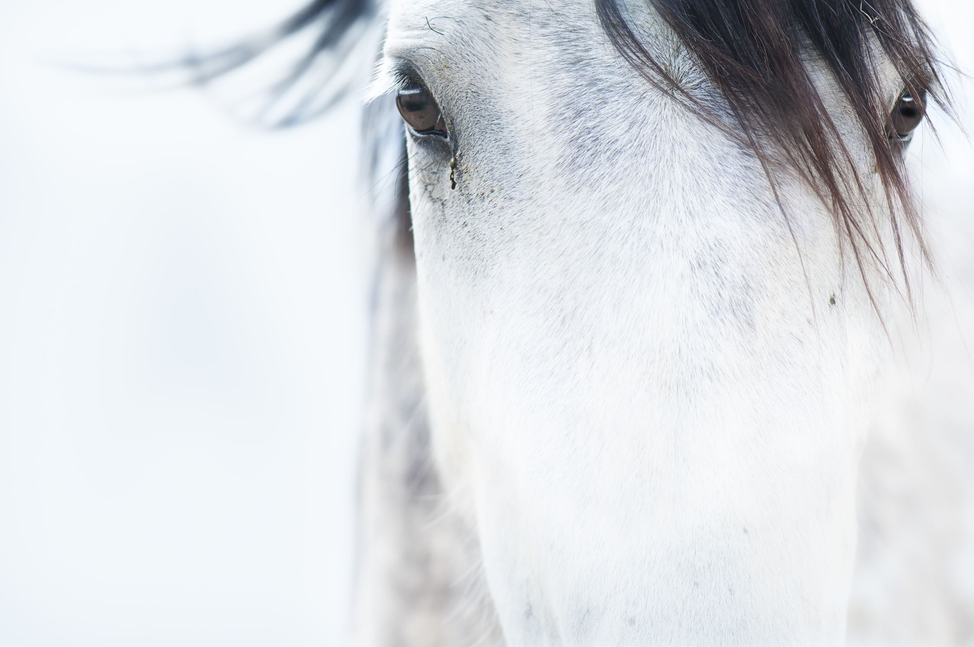

**Australian Brumby Management**

**Organisation**

PO Box 30

Adaminaby NSW 2629

australianbrumbymanagement@gmail.com

**Affiliated Group**

The ABMO has been formed to be an ongoing working group with the following rehomers, sanctuaries and trainers:

|  |  |
| --- | --- |
| *Australian Brumby Alliance (National)* | *Hoofs2010 (NSW)* |
| Brumby Matters Brumby Clinic (National) | Indigo Brumbies (VIC) |
| *Friends of Wild Horses (SA)* | *Orphan Brumby Response Unit (National)* |
| Heritage Horses in Harmony (VIC) | Rivergums Brumby Horses (NSW) |
| *Save The Brumbies (NSW)* | *Snowy Brumby Horsemanship (NSW)* |
| Tir Caim Wildhorse Sanctuary (NSW) | Victorian Brumby Association (VIC) |
| *Waler Database (VIC)* | [*Wild Hearts Equine Massage & Brumby Gentling*](https://www.facebook.com/profile.php?id=100093443292134&__tn__=%2Cd) *(VIC)* |
| White Alpine Equine (NSW) |  |